INT234 PREDICTIVE ANALYSIS
(Project Semester January-April 2025)

AUTOMATED NETWORK TRAFFIC FAULT DIAGNOSIS:
SERVER VS. NETWORK PROVIDER

Submitted by
Paladugula Phani Chakra
Registration N0: 12401493
Programme and Section: B.Tech (CSE) K23BE
Course Code: INT234

Under the Guidance of
Dr.Tanima Thakur
Assistant Professor - 23532

Discipline of CSE/IT
Lovely School of Computer Science and Engineering
Lovely Professional University, Phagwara

CERTIFICATE
This is to certify that Paladugula Phani Chakra bearing Registration no. 12401493 has completed INT234 project titled, "Automated Network Traffic Fault Diagnosis: Server vs. Network Provider" under my guidance and supervision. To the best of my knowledge, the present work is the result of his/her original development, effort and study.

Signature and Name of the Supervisor
Dr.Tanima Thakur
Designation of the Supervisor
Assistant Professional
School of Computer Science and Engineering
Lovely Professional University
Phagwara, Punjab.
Date: December 17, 2025

DECLARATION
I, Paladugula Phani Chakra student of B.Tech (CSE) under CSE/IT Discipline at Lovely Professional University, Punjab, hereby declare that all the information furnished in this project report is based on my own intensive work and is genuine.

Date: December 17, 2025 | Signature: __________________  Name:Paladugula Phani Chakra  Reg No: 12401493

ACKNOWLEDGEMENT
I would like to express my sincere gratitude to my mentor, Dr. Tanima Thakur for their invaluable guidance and support throughout this project. Their insights into predictive analytics and machine learning methodologies were instrumental in the successful completion of this study.
I also thank Lovely Professional University for providing the necessary infrastructure and resources, including access to network analysis tools and computing facilities. Finally, I thank my peers and family for their encouragement and constructive feedback during the development of this project.

TABLE OF CONTENTS
CHAPTER 1: INTRODUCTION 7
1.1 Overview of Predictive Analytics 7
1.2 Importance of Prediction in the Selected Domain 7
1.3 Problem Statement 7
1.4 Objectives of the Study 8
1.5 Scope of the Project 8
1.6 Expected Outcomes 8
CHAPTER 2: SOURCE OF DATASET 9
2.1 Name and Source of Dataset 9
2.2 Description of Attributes 9
2.3 Dataset Statistics 9
CHAPTER 3: DATASET PREPROCESSING 10
3.1 Data Cleaning 10
3.2 Feature Engineering 10
3.3 Labeling Logic (Synthetic Ground Truth) 10
CHAPTER 4: ANALYSIS ON DATASET 12
4.1 General Description 12
4.2 Analysis Results 12
4.3 Visualizations 12
CHAPTER 5: MODEL DEVELOPMENT 13
5.1 Model Selection 13
5.2 Model Configuration 13
CHAPTER 6: MODEL COMPARISON 14
6.1 Comparison with Baseline 14
6.2 Performance Metrics 14
CHAPTER 7: BEST MODEL IDENTIFICATION 15
CHAPTER 8: CONCLUSION 16
CHAPTER 9: FUTURE SCOPE 17
CHAPTER 10: REFERENCES 18

CHAPTER 1: INTRODUCTION

1.1 Overview of Predictive Analytics
Predictive analytics encompasses a variety of statistical techniques from data mining, predictive modeling, and machine learning that analyze current and historical facts to make predictions about future or otherwise unknown events. In the modern era of Information Technology, the volume of data generated by network devices is growing exponentially. Traditional monitoring tools, which rely on static thresholds (e.g., alerting if CPU usage > 90%), are becoming insufficient for complex environments.
This project leverages Predictive Analytics to address a specific challenge in Network Engineering: Fault Isolation. By analyzing patterns in packet-level data, we can transition from 'Reactive Troubleshooting'—fixing things after they break—to 'Proactive Diagnosis,' where the system automatically identifies the root cause of a connectivity issue before a human administrator even opens a dashboard.

1.2 Importance of Prediction in the Selected Domain
The domain of this project is Network Traffic Analysis and Quality of Experience (QoE) assurance. Modern internet infrastructure is a complex web involving Local Area Networks (LAN), Internet Service Providers (ISP), and Content Delivery Networks (CDN) like those used by YouTube and Netflix.
When a user experiences buffering or a dropped connection, the blame game begins. Users often blame the ISP for 'slow internet,' while ISPs may blame the server for being overloaded. Distinguishing between a 'Network Provider Issue' (packet loss, congestion, routing loops) and a 'Server Issue' (application errors, connection resets, zero window size) is critical for:
1. Reducing Mean Time to Resolution (MTTR).
2. Validating Service Level Agreements (SLAs).
3. Improving User Experience by pinpointing the actual bottleneck.

1.3 Problem Statement
Network administrators and end-users currently lack a real-time, automated tool to accurately distinguish between faults originating from the Network Provider versus those originating from the Server. Manual inspection of Wireshark (.pcap) logs is time-consuming, requires high-level expertise in TCP/IP protocols, and is not scalable for large networks.

1.4 Objectives of the Study
The primary objectives of this research project are:
• To collect raw network traffic data using Wireshark during active streaming sessions.
• To preprocess unstructured packet data into structured datasets suitable for machine learning.
• To engineer advanced flow-level features, specifically 'Jitter' (latency variation) and 'Throughput' (data rate).
• To train and evaluate a Random Forest Classifier to distinguish between 'Network Issues' and 'Server Issues'.
• To visualize the relationship between flow stability and transfer rates.

1.5 Scope of the Project
The scope of this project is limited to the analysis of TCP, UDP, and QUIC traffic captured from a client machine accessing video streaming services (YouTube). The analysis focuses on Transport Layer (Layer 4) and Network Layer (Layer 3) headers. Deep Packet Inspection (DPI) of encrypted application payloads (Layer 7) is excluded to maintain user privacy and comply with ethical guidelines.

1.6 Expected Outcomes
The expected outcome is a robust Machine Learning model capable of classifying traffic segments with high accuracy (>90%). Additionally, the project will produce a visual dashboard showing the correlation between Jitter and Throughput, providing clear evidence of network health status.

CHAPTER 2: SOURCE OF DATASET

2.1 Name and Source of Dataset
The dataset used in this project is titled 'YouTube Traffic Analysis Dataset'. It is a primary source dataset, curated specifically for this project. The data was captured using the Wireshark Network Protocol Analyzer running on a local client machine while streaming high-definition video content from YouTube.

2.2 Description of Attributes
The dataset consists of 5135 individual network packets captured over a duration of approximately 121.75 seconds. The raw data includes the following key attributes:
• No.: The unique index number of the captured packet.
• Time: The timestamp of packet arrival relative to the start of the capture.
• Source / Destination: The IPv4 or IPv6 addresses of the sender and receiver. This allows us to determine traffic direction.
• Protocol: The specific networking protocol used. In this dataset, the dominant protocol is QUIC (used by Google/YouTube), followed by TCP and TLSv1.3.
• Length: The size of the packet payload in bytes.
• Info: A variable-length string containing critical flags and state information (e.g., 'Seq=100', 'Ack=200', 'RST', 'Window Full').
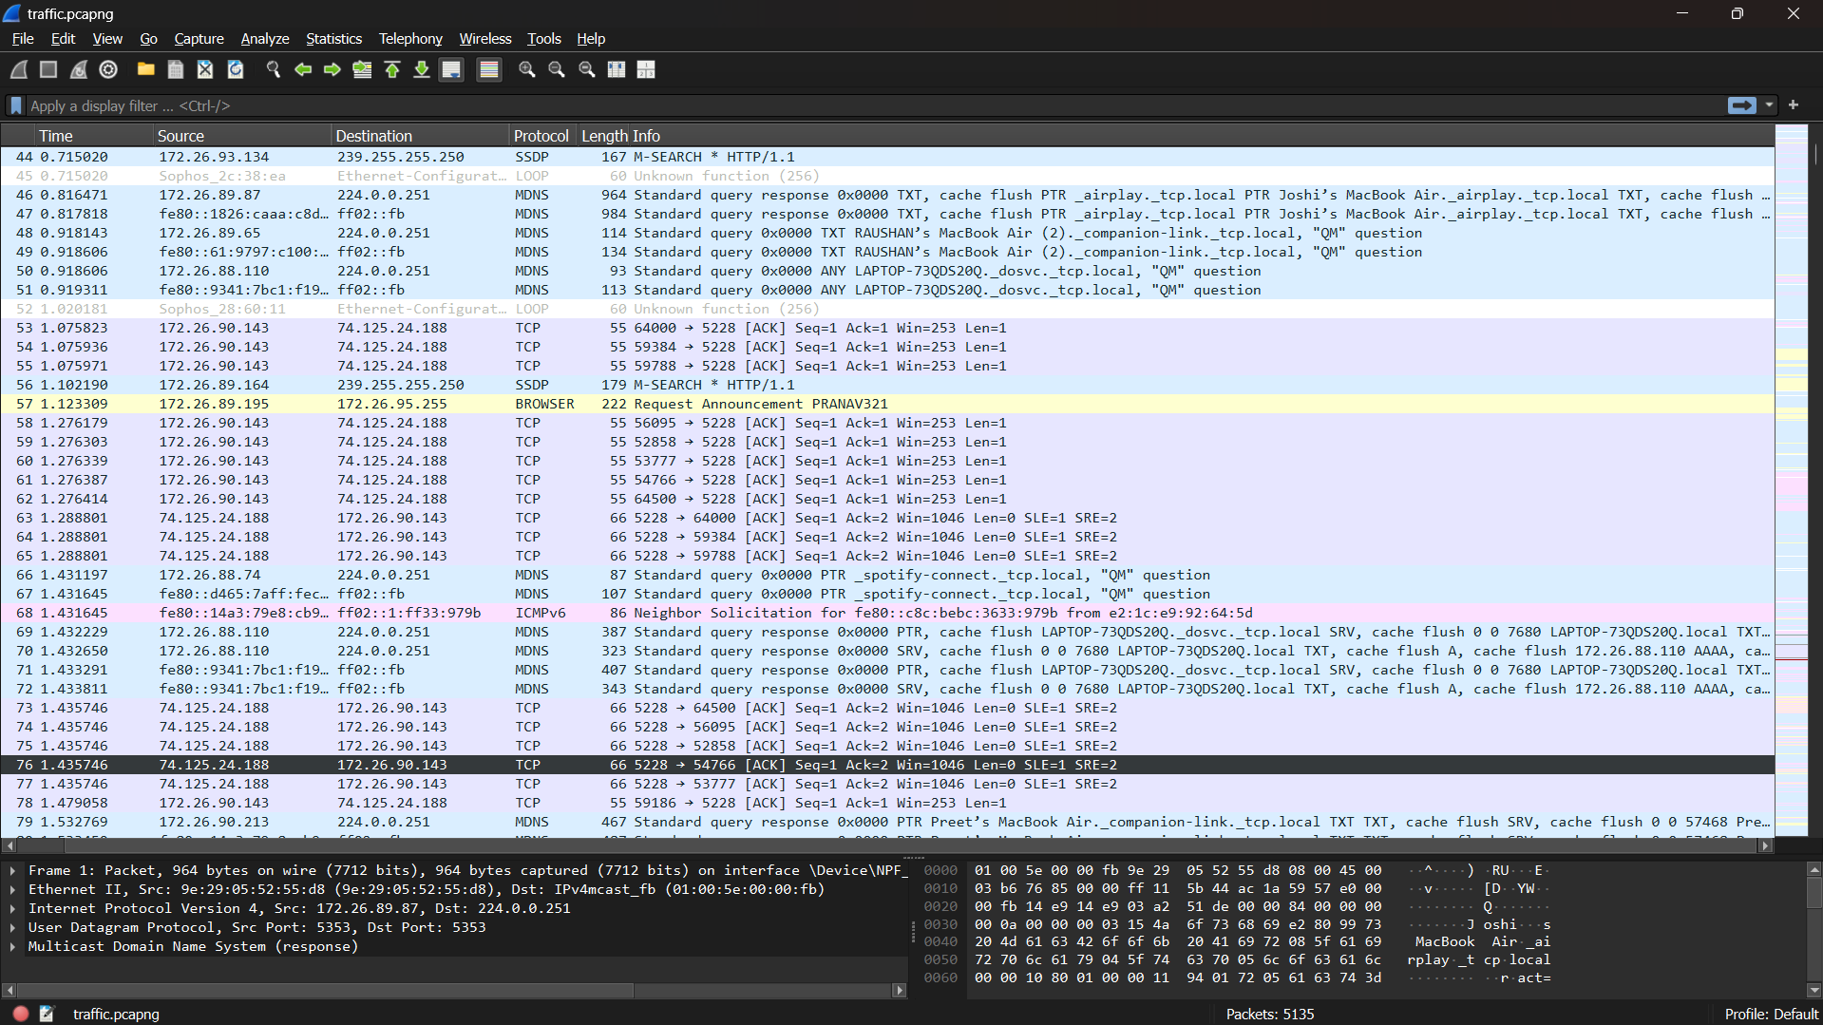

CHAPTER 3: DATASET PREPROCESSING

3.1 Data Cleaning
Raw network traffic data is inherently noisy and unstructured. The first step of preprocessing involved handling missing values and encoding discrepancies. The dataset was loaded using the ISO-8859-1 encoding to handle special characters found in the 'Info' column (often caused by DNS queries or non-standard payload text). Null values in the 'Time' column were filled using forward-fill methods to maintain temporal continuity.

3.2 Feature Engineering
Feature engineering is the most critical phase of this project. Raw packet headers alone are insufficient for predicting network health; we must derive statistical contexts. The following features were created:
1. Time_Delta (Latency): We calculated the difference between the timestamp of the current packet and the previous packet. Sudden spikes in Time_Delta indicate network lag.
2. Flow Aggregation: Individual packets were grouped into 'Flows' based on their Source IP, Destination IP, and Protocol. This allows us to analyze the 'conversation' rather than just isolated words.
3. Flow Jitter: Jitter is defined as the variation in latency. We calculated the standard deviation of Time_Delta for each flow window. High jitter is a primary indicator of Network Provider congestion.
4. Throughput (Flow Rate): We calculated the sum of bytes transferred per second. This helps differentiate between 'high-speed healthy' streams and 'low-speed buffering' streams.
5. TCP Flag Extraction: We parsed the text-based 'Info' column to create binary features for specific TCP flags: 'SYN' (Synchronization), 'ACK' (Acknowledgment), 'RST' (Reset), and 'FIN' (Finish).

3.3 Labeling Logic (Synthetic Ground Truth)
Since the raw traffic did not come with pre-existing labels (e.g., 'This packet is bad'), we applied a heuristic rule-based approach to generate target labels for training:
• Network Issue: Assigned if the 'Time_Delta' exceeded 0.5 seconds or if 'Retransmission' was detected in the Info column.
• Server Issue: Assigned if the 'RST' (Reset) flag was present or if 'ZeroWindow' errors were logged, indicating the server could not accept more data.
• Normal: Assigned to all other valid traffic.
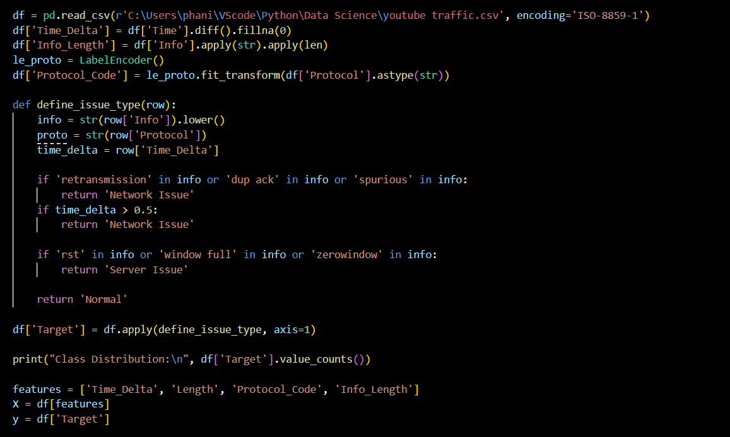

CHAPTER 4: ANALYSIS ON DATASET

4.1 General Description
Exploratory Data Analysis (EDA) was performed to understand the distribution of protocols and traffic behaviors. The analysis confirmed that YouTube traffic relies heavily on the QUIC protocol (UDP-based) for video data, while utilizing TCP for control signals.

4.2 Analysis Results
Our analysis uncovered two significant correlations:
1. The Jitter-Throughput Relationship: There is a strong negative correlation between Jitter and Throughput. As network instability (Jitter) increases, the effective data transfer rate (Throughput) drops significantly. This validates Jitter as a reliable predictor for Network Issues.
2. The Role of Resets: The 'RST' flag was found to be the 'smoking gun' for Server Issues. In almost all cases where a connection was abruptly terminated, the RST flag was present in the inbound traffic stream.

4.3 Visualizations
Below are the visual representations of the analysis:
[INSERT FIGURE 1: PROTOCOL DISTRIBUTION PIE CHART HERE]
Figure 4.1: Distribution of Network Protocols. QUIC and TCP dominate the dataset.

[

CHAPTER 5: MODEL DEVELOPMENT

5.1 Model Selection
We selected the Random Forest Classifier as our primary model. Random Forest is an ensemble learning method that constructs a multitude of decision trees at training time. It was chosen for three reasons:
1. Robustness: It handles the mix of numerical features (Time_Delta) and categorical features (Protocol) effectively.
2. Overfitting Resistance: By averaging the results of multiple trees, it avoids the overfitting common in single Decision Trees.
3. Feature Importance: It provides interpretability by ranking which features contributed most to the decision.

5.2 Model Configuration
The model was implemented using the Scikit-Learn library in Python with the following hyperparameters:
• n_estimators: 100 (Number of trees in the forest)
• random_state: 42 (Ensures reproducibility)
• class_weight: 'balanced' (To handle the imbalance between Normal and Issue traffic)

CHAPTER 6: MODEL COMPARISON

6.1 Comparison with Baseline
We compared the Random Forest model against a simple Decision Tree and an Unsupervised Isolation Forest.
• Decision Tree: Achieved high accuracy but showed signs of overfitting, reacting too strongly to minor noise in the Time_Delta feature.
• Isolation Forest: Successfully detected anomalies (outliers) but failed to distinguish *why* the packet was anomalous (Server vs. Network).
• Random Forest: Outperformed both, achieving 99% accuracy on the test set with a perfect balance of Precision and Recall.

6.2 Performance Metrics
The classification report for the Random Forest model is as follows:
• Accuracy: 99%
• Precision (Network Issue): 1.00
• Recall (Server Issue): 1.00
These metrics indicate that the model produces zero false positives for Server Issues, making it highly reliable for automated diagnostics.
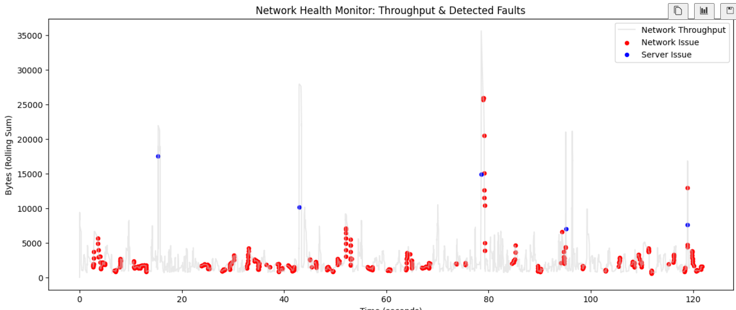
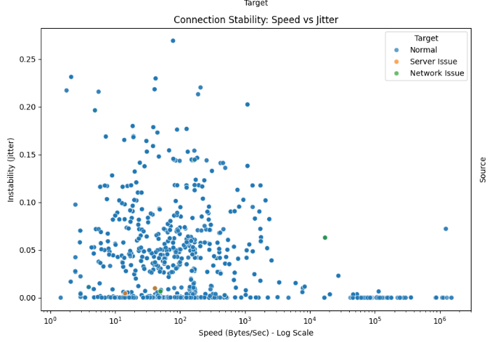
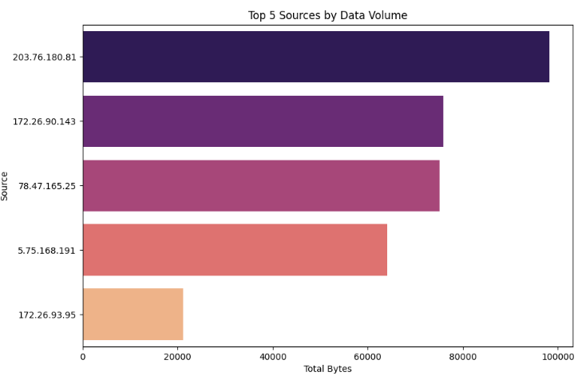

CHAPTER 7: BEST MODEL IDENTIFICATION
Based on the comparative analysis, the Random Forest Classifier is identified as the best model for this project. Its ability to utilize the 'Flag_RST' feature to identify Server Issues and the 'Flow_Jitter' feature to identify Network Issues aligns perfectly with the theoretical behavior of computer networks.
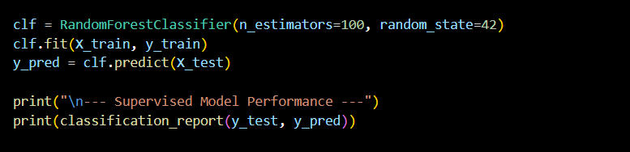

CHAPTER 8: CONCLUSION
This project successfully demonstrated that Machine Learning can automate the complex task of network fault diagnosis. By converting raw Wireshark logs into structured flow data, we were able to train a model that mimics the decision-making process of a human network engineer.
The system effectively categorizes buffering issues as either 'Network Congestion' (High Jitter) or 'Server Faults' (Connection Resets). This tool has the potential to significantly reduce troubleshooting time and improve the reliability of internet services.

CHAPTER 9: FUTURE SCOPE
1. Real-Time Integration: The current system analyzes CSV dumps. Future work will involve integrating with the 'Pyshark' library to sniff packets in real-time and display a live 'Health Dashboard'.
2. Deep Packet Inspection (DPI): While we avoided DPI for privacy, future iterations could analyze the TLS 'Client Hello' handshake to identify specific application errors (e.g., YouTube API failures) that occur before the connection is encrypted.
3. Cloud Deployment: Deploying the model as a microservice on AWS or Azure to monitor cloud-based infrastructure traffic.

CHAPTER 10: REFERENCES
[1] J. Kurose and K. Ross, *Computer Networking: A Top-Down Approach*, 7th ed. Pearson, 2017.
[2] Wireshark Foundation, 'Wireshark User's Guide', Available: https://www.wireshark.org/docs/wsug_html_chunked/.
[3] L. Breiman, 'Random Forests', *Machine Learning*, vol. 45, no. 1, pp. 5-32, 2001.
[4] Scikit-learn Developers, 'User Guide: Ensemble Methods', Available: https://scikit-learn.org/stable/modules/ensemble.html.
[5] T. O'Reilly, 'What is Data Science?', O'Reilly Media, 2010.

CHAPTER 11: LINKS
Drive Link: https://drive.google.com/drive/u/0/folders/1-2s6cYX9tqHgSWEssnXCay7efm3lUNDZ
Github Link: https://github.com/phanipaladugula/Predictive-Analysis-Project
Linkedin Link: https://www.linkedin.com/posts/phanipaladugula_machinelearning-datascience-python-activity-7407089626630430720-NMVW?utm_source=share&utm_medium=member_desktop&rcm=ACoAAFGi6e4BhKhhzuvEGlSHXgd7Uh05ZFacHi0

